**CN LAB#10**

**Name: Saman Khan**

**ID: 19K-0354**

**Section: H**

**Question#01:**

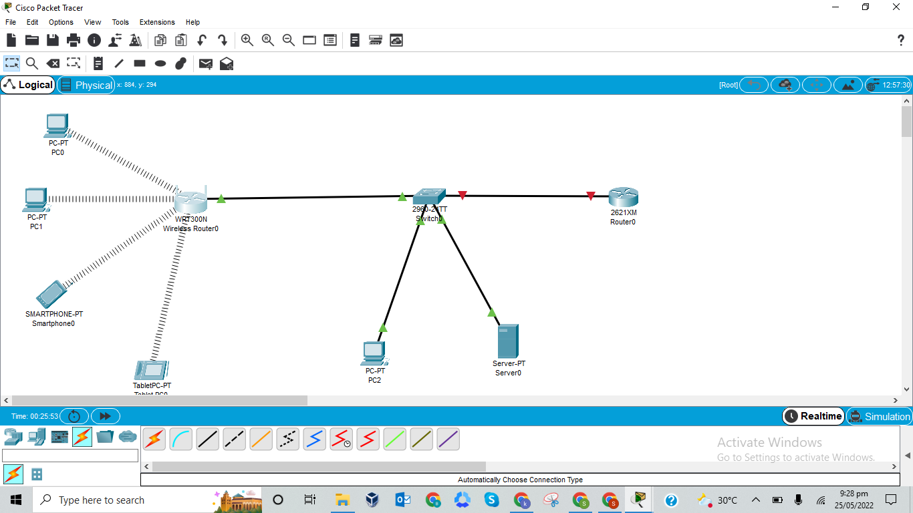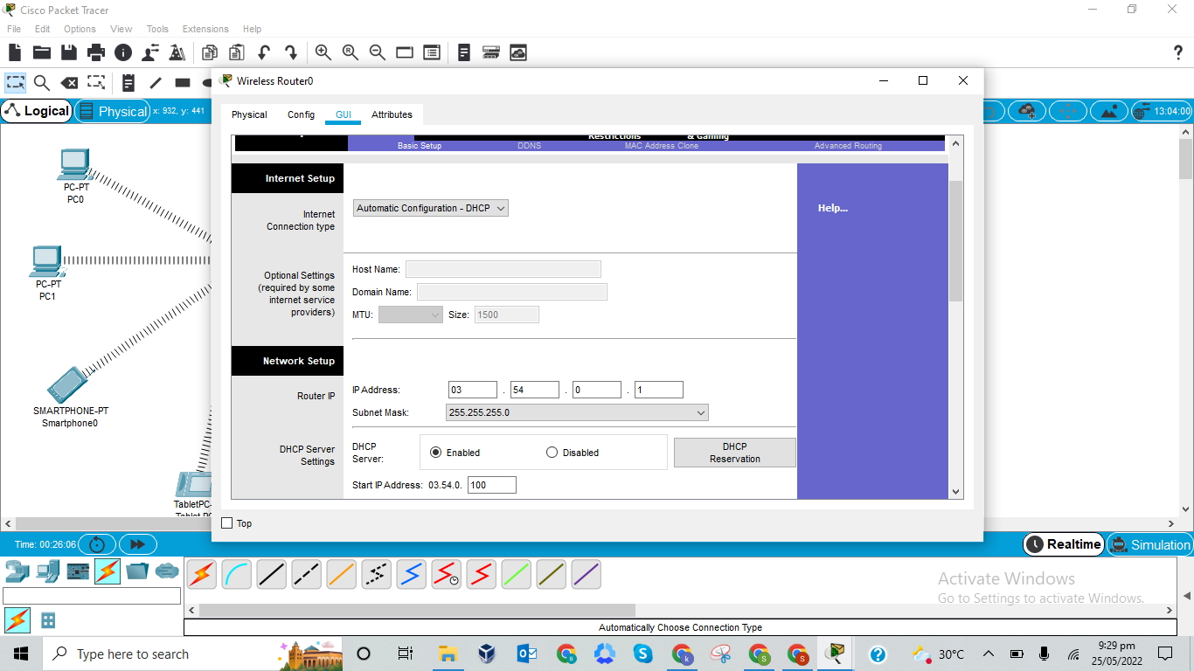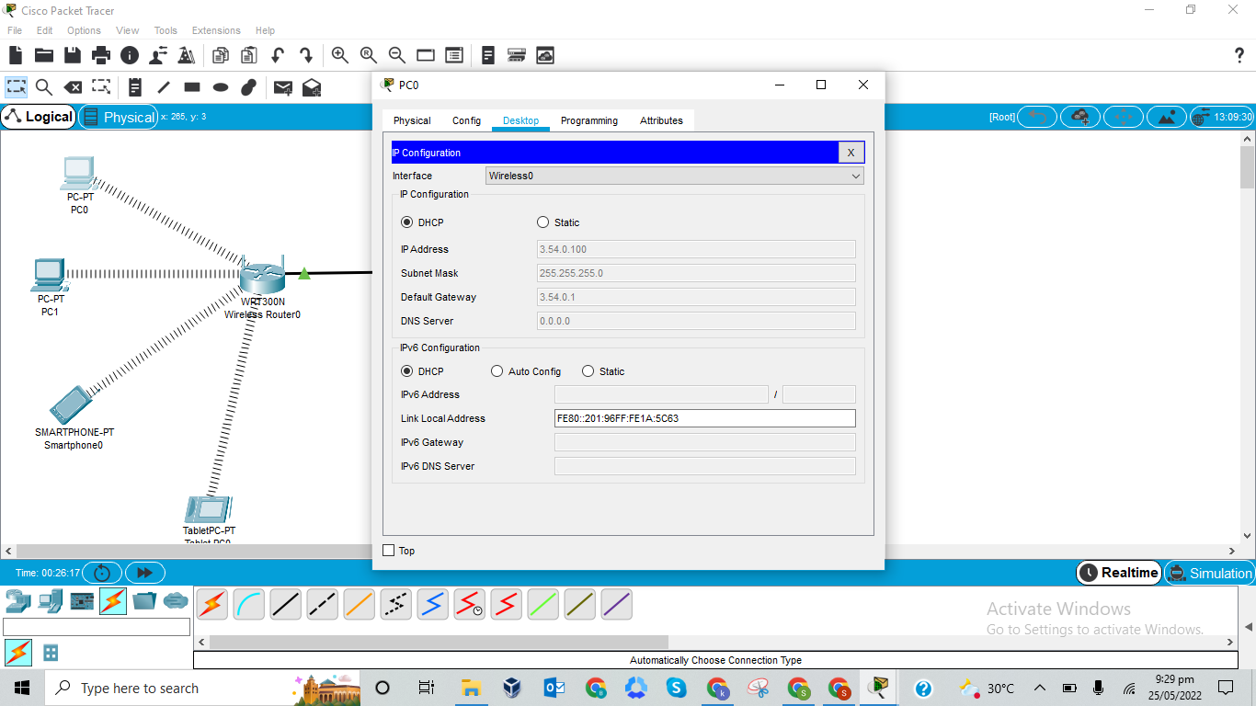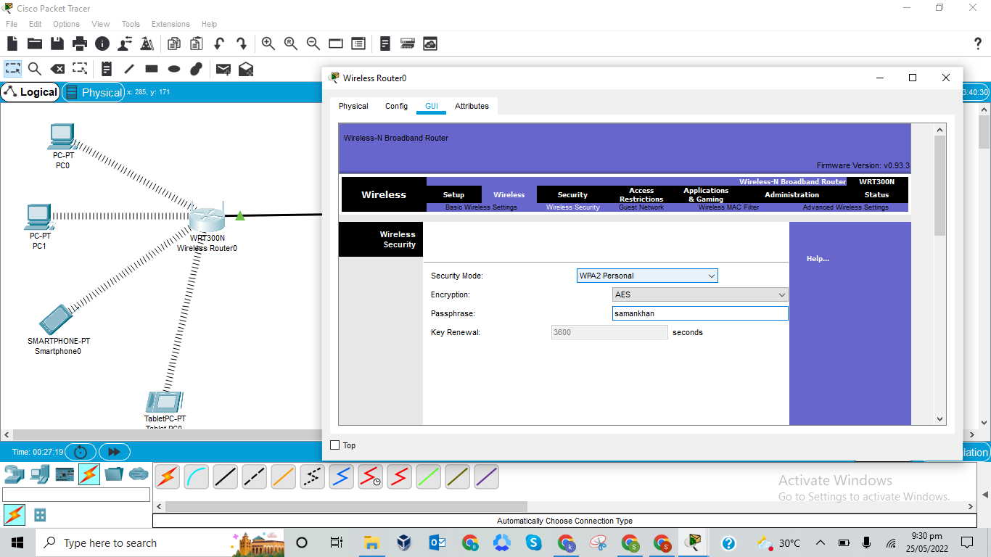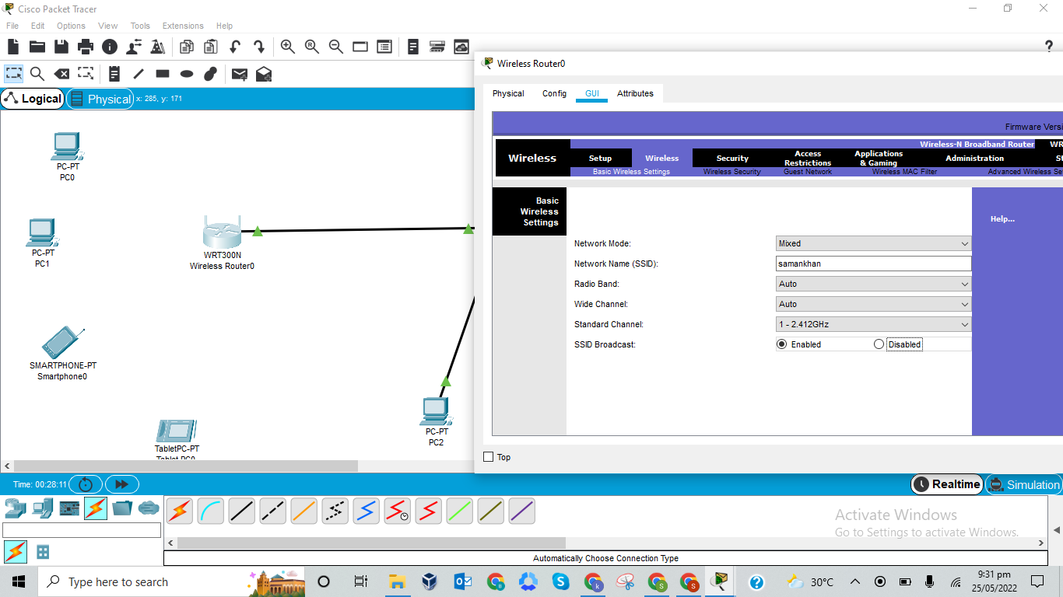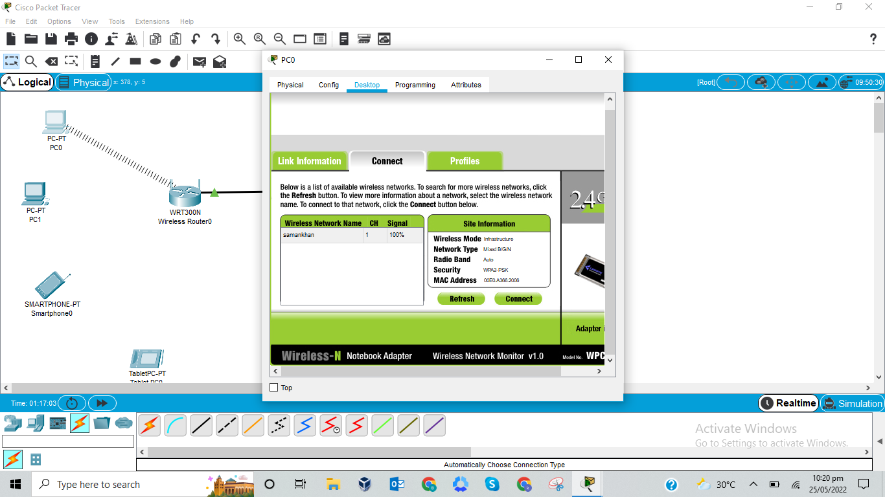

**Question#02:**

1. 192.168.1.100

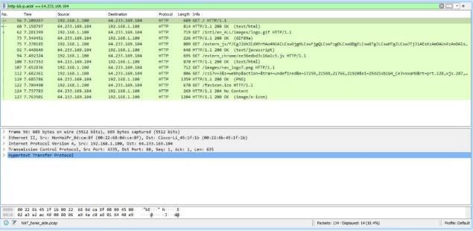

1. **Source:** 192.168.1.100  **Port:** 4335

**Destination:** 64.233.169.104  **Port:** 80

1. **Source:** 64.233.169.104  **Port:** 80

**Destination:** 192.168.1.100  **Port:** 4335

1. D
2. 7.075657
3. **Source:** 192.168.1.100  **Port:** 4335

**Destination:** 64.233.169.104  **Port:** 80

1. **Source:** 64.233.169.104  **Port:** 80

**Destination:** 192.168.1.100  **Port:** 4335

1. 7.108986

**Question#03:**

